Account Opening Process Study
Findings and Recommendations v 1.2

Sarah Barbour
CAPE
October 18, 2019
Contents
Executive Summary 4
Cross-Branch Validation Interviews (Conducted August 2019) 6
Edmonton Main Time Motion Study (Delivered June 2019) 9
Executive Summary 9
Data Gathering Approach 9
Objective and Scope 9
Limitations 9
Business Line Analysis – Findings and Recommendations 10
Personal 10
Non-Personal 16
Account Opening Current State Assessment and Self Reported Data Gathering (Delivered April 2019) 20
Executive Summary 20
Approach 20
Demand Account Opening 23
Personal 23
Personal – Motive 27
Business 29
Investment Account Opening 33
Personal 33
Business 36
Credit Account Opening 39
Regulatory Processing AML Audit 43
Recommendations and Proposed Next Steps 44
Appendix II-A - Scope 45
Appendix II-B – Volume Data Analysis 46

Executive Summary
As part of Business Process Review, a current state assessment of the Account Opening process was conducted to gain a deeper understanding of the process performance and pain points experienced by our staff and clients. This assessment included each client type – Personal and Business – and account category – Demand, Investment, and Credit. While the findings provided insight into the key areas of frustration from the branches, the self-reported cycle times for each step raised a number of questions around the validity and prioritization of potential process improvement opportunities. As such, a time motion study was conducted to gather objective cycle time data and gain a deeper understanding of where opportunities exist to improve the process performance, their FTE impact, and the pain points that might be addressed as a result.
As the time motion study took place at Edmonton Main, employees from other branches were interviewed to gather feedback on the degree to which the information gathered was consistent with their experience. While there was some additional context provided, the findings were validated by all participants.
Overall, the study did not find that there were significant process optimization opportunities resulting in FTE savings. However, other possibilities exist to revamp account opening and produce a different client and employee experience:
- Digital account origination – this is on the project roadmap for 2020 and is expected to transform the process. This study and other supporting artifacts will be leveraged by the Digital and Alternative Channels team to provide the current state information required may expedite the implementation.
- COMET – this project, which will consolidate and streamline cash management product onboarding, does not impact account opening directly as the scope does not include integration with T24. However, as it will have a positive impact on business client onboarding where cash management products are sold with a new account, there is expected to be a ‘halo’ effect.
- Reinforcement – the study highlighted some common misconceptions and areas where the process or procedures are not being followed (such as investment account renewals), leading to longer cycle times and employee frustration. For these areas, the development of training aids or checklists may be considered to ensure a common baseline performance across the organization.
- AML errors – the results of this study supported the findings of the AML Defect rate Lean Six Sigma (LSS)project and provided additional context. Improvements related to targeted training and cleanup of data errors originating from the conversion from BFE/HOBS to T24 are part of the LSS project and are in the pilot and planning phases respectively.
- Authorizations and Master Review – For the purposes of this report the term Authorization refers to the T24 requirement to have a user with the appropriate access “authorize” a transaction, allowing it to continue to progress within the system. Tthe findings around authorizations highlight the lack of a cohesive and streamlined controls framework for account opening. The data and impact assessment outlined in the study highlight the opportunities available for the future state – the authorization procedures are being completely bypassed, but the users expected to complete the authorization do not seem to be clear on what is expected of them. This information has been provided to the Retail TOM project, which is also reviewing this framework.

Recommendations – Personal
While opportunities exist to streamline the account opening process, the short work duration and limited transactional volume restrain the potential benefit realization. Enforcing either the authorization or master review process to eliminate redundancy and simplify reporting may have a positive impact on the AML deficiency rate and remove a point of frustration for the branches. Employees need to understand that compliance with regulations such as AML are a base expectation that clients have around how CWB is protecting their interests and are the foundation from which our services and customer relationships should be built from. This opportunity is also expected to be highlighted as a result of the Retail TOM workshops.
The model developed by Abbotsford, where tasks are completed concurrently, should be considered in more detail to understand the benefits, the impact to client experience, and the cost/benefit of leveraging resources that are required for front-line tasks but have down-time in between serving clients. This model may provide insight into opportunities for centralization of tasks in real-time, or potential approaches for leveraging branch operations when idle and increasing their value-add time.
The most significant area of potential time savings exists in the investment product renewal/rollover process, ensuring that employees are leveraging any automation opportunities in T24 through training and reinforcement, and revisiting the process to align with a more proactive approach. As the future state solution and process for Retail mortgage renewals within BPR is finalized, there may be opportunities to apply some aspects to term renewals processing and client experience.
While it may be cost prohibitive, the simplest and highest impact improvement may be in relocating printers to be closer to the client facing retail teams, or in providing them with their own printers.

Recommendations – Non Personal
There are two areas of non-personal account opening that could provide opportunities for reducing the total lead time – queue time waiting for the client, and beneficial ownership. Although this is an area that CWB is least advanced in leveraging compared to other FIs, tools and technology such as e-signature capabilities, document portals, or digital information input (ie online forms or user interface) might be explored to make it easier for clients to meet our requirements. This would have a significant impact on client experience and should be considered in the context of our desired future state.
Beneficial ownership is a significant area of frustration, confusion, and time spent. Inefficiencies observed appear to be related to lack of knowledge rather than a fundamentally broken process – employees are unsure of when to use the Declaration of Beneficial Ownership form, are unable to explain to clients why some information is needed, and have not demonstrated proficiency in completing this analysis, even in a high volume branch such as Edmonton Main. These characteristics suggest an opportunity for consolidating this task within a small group who can build the knowledge base required to complete the analysis and develop corresponding economies of scale.
There are some minor areas of opportunity – any enforcement of the authorization or master review process should also consider non-personal account opening in scope. In addition, revisiting the distribution and collection of the FATCA forms may alleviate a small pain point – as such this is being considered within the Business Process Review project to develop a tool to streamline FATCA reporting.
Below is a summary of the highlights of the time motion study, the details of the validation interviews, and the improvement opportunities found. The details of the time motion study and the original current state follow.

Cross-Branch Validation Interviews (Conducted August 2019)
As the results of the time motion study were specific to Edmonton Main, interviews were conducted with branches of differing size, structure, and geographic location to determine the extent to which findings and assumptions can be more broadly applied.

Personal

Findings
Based on the time motion study, opening a demand account for a new client takes approximately 50 minutes from the start of the client meeting through to the account being available in T24, including needs analysis. If the client is existing, it will take about 22 minutes less as there is time savings in the Info Gathering and Create/Update CIF steps, If the account is a new investment account, it will take an additional 9 minutes to Prepare and Print forms. It should be noted that the data collected in the time motion study revealed cycle times of about half of what was provided in self-reporting questionnaires delivered in the original current state assessment.
While there was very little time recorded against Authorizations, this is a completely non value-add step as any checking or information validation is deferred to the Master Review report processing as opposed to real-time. Study participants at Edmonton Main expressed frustration with the format and content of the Master Review report – this feedback was also captured in the Retail TOM workshops. Given the AML deficiency rate of 6.27% at Edmonton Main despite having both authorizations and Master Review checks, the effectiveness of the time spent on the in-branch audit and remediation should be questioned, and underscores the need to enforce one approach or the other.

Concurrence
Interviews were conducted with the following retail team members to review and validate findings:
- Alexandra Kolyadenkov, Senior Retail Services Officer – Calgary Chinook
- Crystal Nicholson, Retail Account Manager – Abbotsford
Both were in agreement that the cycle times for each process step captured at Edmonton Main were reflective of their experiences. However, Calgary Chinook suggested that if the client had additional complexity to the setup, such as spouses or parent/child shared ownership over the account, the process could take 1.5 times as long (75 minutes). In these instances, the practice was to gather the information from the client and schedule the appointment for the following day, allowing the RSO time to prepare the required forms. This practice ensured that for these more complex scenarios, the RSO was able to dedicate a high degree of attention and focus to this activity rather than multitasking while conversing with the client.
Calgary Chinook has put in place a process similar to Edmonton Main, requesting authorizations in a mass communication actioned by the first available team member. This has alleviated the pain of having to find an authorization to continue the client transaction. However, as with Edmonton Main, the authorization is a system function and no real-time audit or checking activity actually takes place. The most significant frustration expressed by Calgary Chinook was not having a printer in the RSO’s office to print client documentation. The process of leaving the client to retrieve and review documents from a central printer was seen as painful and a poor client experience. The time and frustration was compounded if there was an error on the documentation that required revising, or the settings printed the documents incorrectly (IE single vs double sided).
While Abbotsford did concur with the timings collected, they have taken the approach of stacking tasks concurrently, outsourcing some steps to cross-trained front line employees while account managers are conducting information gathering discussions. For example, once the Account Manager has gathered the required information to conduct a credit check and build a CIF, they will pass it off to an SSR to complete these activities while the needs discussion takes place. This approach has resulted in an end-to-end elapsed time of approximately 30 minutes (self-reported).
Abbotsford shared the same perspective as the other branches around authorizations and the difficulty in working with the master review report, although their main pain point revolved around GIC rollovers. The team had challenges in the past that have led them to follow a manual process of paying out and recreating rather than leveraging automated processes in T24. . There was some frustration around the perception that they are required to manually calculate the rate on a wholesale GIC auto-renew, although it has been verified with Operations that this should not be required if the process was followed correctly.

Non-Personal

Findings
The most significant finding in the non-personal time motion study was the ratio between the total lead time and working time. As observed at Edmonton Main, the account opening lead time from start to completion was approximately a month, with a small proportion of this (approximately one working day) being actual working time by a CWB employee. The remainder of the time was spent waiting for the client to provide information or return signed forms. The specific duration may be specific to Edmonton Main’s client base, or the specific transactions observed, but this strongly suggests that non-personal account opening is a process that is driven by the client.
The most significant area of confusion, and approximately half of the working time spent for non personal account opening, was completing the beneficial ownership requirements. This step was a major source of frustration and confusion, especially in the case of complex clients, which could take much more time and effort to analyze and complete. The authorization/master review issue described above was also a pain point for non-personal accounts.

Concurrence
Interviews were conducted with the following cash management team members to review and validate findings:
- Lisa Sabiston Larsen, Account Manager, Cash Management – Saskatoon North Landing (SNL)
- Suzanne McManus, Account Manager, Cash Management – Park Place
Both employees interviewed were comfortable with the cycle time metrics captured at Edmonton Main. SNL felt that their queue times were shorter and clients were turning around forms and information requests more quickly than what was observed at Edmonton Main. SNL branch’s process illustrates a different and much more time-consuming approach to authorizations than Edmonton Main. At this branch, the Account Manager was required to find someone in the branch that could assist and wait for their time to be free each time an authorization was needed, rather than having an open and monitored request communication channel. SNL also had a similar approach as Edmonton Main to collecting FATCA forms, providing them to the client upon account opening. However, as no formal arrangement has been made with Regulatory Compliance to stop sending the forms, their clients are instructed to disregard the correspondence upon receipt. Park Place follows this approach as well.
While Park Place was in agreement with the times presented, they pointed out that they sometimes deal with high complexity, multi-CIF clients. These account opening transactions may require significant more time to complete beneficial analysis, which can be a multi-day process. The more CIFS that are required, the longer the cycle time in each step of the process. These complex cases may account for the pain points in the beneficial owner step and significant time estimates that have been previously provided. Park Place also expressed frustration at having little ability to influence the client to provide documents or information in a timely manner, as there is no ‘carrot or stick’, with the exception of a loan funding.

Edmonton Main Time Motion Study (Delivered June 2019)

Executive Summary

The results of the time motion study completed in June 2019 highlight a number of opportunities for process improvement. The majority of these opportunities have already been raised, but can now be more directly quantified. There are some areas, such as forms and authorizations, which apply to both Personal and Non-Personal.
While opportunities for abandonment of non-required activities were sought, unfortunately none were observed with the exception of a GIC renewal form, which is highlighted below.

Data Gathering Approach

Objective and Scope
In order to gather data on the cycle times and queue times within the account opening process, a time motion study was conducted from June 4-14, 2019 at Edmonton Main (some data gathered between June 17-28). The objective was to identify areas of opportunity for the future state and compare these timings against self reported data gathered during the Account Opening Current State Assessment conducted in March/April 2019.
The scope of this time motion study included the below account types, and sought to gather information on all scenarios - new versus existing CIFs and various levels of complexity (single CIF versus joint account, sole proprietor versus corporation):

- Personal CIF/account opening
  - Demand accounts
  - Investment accounts
  - Credit (loan only) accounts
- Non-Personal CIF/account opening
  - Demand accounts
  - Investment accounts
  - Credit (loan only) accounts

Limitations
The duration of the time motion study was based on gathering ten data points for each type noted above and the volume of activity in June 2018. However, data collection was constrained by the actual level of customer activity during the study both in terms of volume and mix, with branch SMEs indicating that volume was much lower than expected during the period of study. To mitigate this, some data gathered for Non-Personal account opening was based on email timestamps.
The study was located at Edmonton Main (with some secondary data collection from Edmonton 103rd), which means that all data is reflective of their practices and level of expertise. Edmonton Main has been observed to be generally proficient in their performance, which supports the contention that opportunities that exist there are likely to be present in other branches, which may not be the case if branches with lower volume or less expertise were studied instead.

Business Line Analysis – Findings and Recommendations

Personal

Data - Volume
Data points were collected for personal account opening as follows:
 | Account Type
Client Type | Demand | Investment | Credit
New | 1* | 0 | 1
Existing | 1 | 5 | 0
* only Multi-CIF transaction
As the sample size is small and the transactions are similar, all data has been combined except where noted. Variances in process requirements between the account opening types are noted where relevant, and any relevant differences between New and Existing have been called out.

Data – Lead Time
Lead times as calculated from the time motion study are found in the below chart, which represents the amount of time spent on each activity within a one-hour timeframe. Both scenarios refer to new account openings but in the first instance the client is new, and in the second a CIF has already been set up.
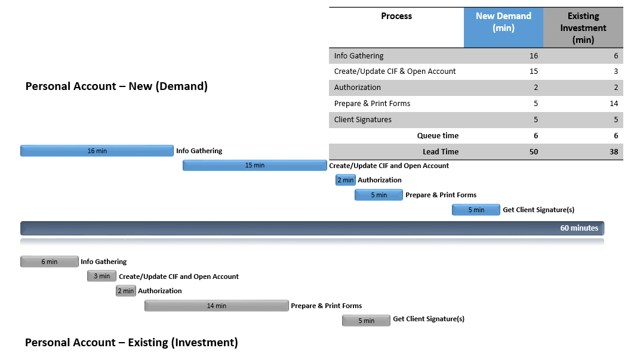
Master review time was not collected for Personal accounts as it was a task that was completed intermittently throughout the day. The gathering and input of AML requirements were captured in Info Gathering and Create/Update CIF and Open Account and could not be isolated individually due to the method of process execution. The time study resulted in a lead time of about half of that collected in self-reporting gathered in March 2019.
As the majority of data collected for new account opening was for Demand accounts and Credit CIF creation (which is an identical process for the relevant steps), the information provided should be considered specific to that account type. Conversely, the data collected for existing accounts was primarily for Investment and as such are representative of the needs of that product category. Once the differences between the requirements for an Investment and Demand account opening are understood, data from each set can be combined to understand different scenarios. For example, the time required to Prepare and Print Forms for the Existing Investment account opening can be extrapolated to apply to New:
Process Step | Demand | Investment
Gather Documents | Credit bureau is pulled | Credit bureau is not pulled
Print and Prepare Forms | Most forms are printed off from T24. Some are pre-filled. | Forms are standalone from InfoServer. All require manual completion.

While the process is depicted as linear, there were some isolated occasions of concurrent processing. Team members were observed requesting authorization while commencing forms preparation. However, it should be noted that the Operations Manual requires that all documents be signed prior to requesting authorization, as verification of document completion is part of the authorization process as currently prescribed.
The process and timing captured is specific to Edmonton Main and is reflective of their structure, challenges and advantages. For example, while authorizations are found to be ineffective (see below for details), they represent only 4% of the lead time of an account opening for a new client at two minutes. In branches with fewer employees with authorization capabilities the time spent seeking and completing an authorization may be higher.

Observations and Pain Points
Through the timing data collection, a number of process issues were observed or referenced by the branch team and are noted below. These observations reflect differences between the process as executed and as documented, or deviations from process best practices. Those raised by the branch are noted as Pain Points. It is important to note that pain points are based on the perception of the respondent. While this is an excellent indicator of the mindset of those performing the process, they reflect a set of feelings and viewpoints and not facts. As such, certain limitations should be understood when reviewing them:
- Pain points expressed may be based on a recent or particularly painful experience rather than the common experience
- Pain points may reflect a misunderstanding of policy, documented procedure, or system function. They may be factually incorrect or based on the wrong premise.
- Pain points often reflect the symptom, not the cause. Those expressing pain points are articulating the impact.

Observation 1: Authorizations are applied ineffectively
Details: The retail team uses a team chat to request someone from the team to authorize. The authorization provided is blind; no documentation is in front of the authorizer to verify. In addition, someone must complete an end-of-day check to ensure no authorizations are still waiting and action as necessary.
Impact: The authorization request could be missed on the chat, increasing the queue time. The interruption that it causes the authorizer may also have a downstream impact on the work they are engaged in at that time. Any errors that might be caught are deferred to the Master Review which takes place the following day, , although a prevailing interpretation of the Operations Manual states that inputs requiring authorization should not be checked as part of the Master Review. The end of day check is to ensure no system issues arise as a result of incomplete authorizations, and if one is missed, a Helpdesk ticket is required to remediate.
*Edmonton Main was not observed putting a hold on a personal account at time of opening, which is a known and reportedly used workaround to ensure that the account opening documents retain the assigned account number over month end, and requires two additional authorizations. The transaction was completed real-time and in person, making the step irrelevant.

Observation 2: Forms are numerous and difficult to identify and generate
Details: The number of forms that are produced to complete a demand account opening transaction are significant at six (four of which require populating), and may represent overproduction of required information if the same data is entered multiple times. Forms must be manually selected based on the transaction and are located in multiple places, including T24, CRA website and InfoServer. Many forms must be printed for signature and/or to provide to the client – the branch employee must pause any conversation and leave the client to retrieve them from a community printer.
Impact: Each form requires time and effort to complete. Any non value added or repetitive information (or form) adds cycle time and introduces opportunity for error. It also may not reflect the desired client experience. The interruption to retrieve forms from a community printer may also impact the client experience as well, in addition to introducing the potential for documents to get mixed up (this is more relevant in a large and busy branch such as Edmonton Main). If there is an error in a form, including populating the incorrect form, the branch employee will not know until they retrieve and review the forms with the client, and must go through the production and printing process again.

Observation 3: T24 has not been error-proofed for data entry or optimized for workflow
Details: T24 does contain hard stops, but the reason for the hard stop is not always provided and may be difficult to identify without consulting resource materials. Many fields are not dynamic based on selections in other fields, or were never defined as mandatory based on the use case. The screens requiring input and review are separated and must be accessed individually. There are parts of the process, such as GIC creation, that require a manual copy/paste of data from other areas of T24.
Impact: The existence of multiple points of failure in the form of transposing/copying data, troubleshooting issues where a hard stop exists in order to continue on with the process with little on-screen guidance, and navigating to multiple screens to access or input required information are contributing to the AML failure rate, according to an ongoing Lean 6Sigma project. However, it should be noted that remediating this within T24 is not recommended due to the prohibitive cost and incremental return. The preferred approach is to leverage a simplified digital front end tool that pushes the required information directly into T24.

Observation 4: Master Review Report is not optimized to reflect audit requirements
Details: The report contains duplicate counts that do not require review, and legacy data issues from BFE to T24 conversion, which causes the report to be quite large and requires the user to filter through the records to find those requiring action. In addition, despite the Operations Manual statement that is generally interepreted as excluding items requiring authorization from the scope of Master Revew, all line items on the report are checked.
When reviewing records pertaining to CIF changes, the full scope and detail of changes are not listed on the report. The user must go into the CIF and drill down to find each change. This requires the user to find the change, then exit the CIF and start again.
Impact: The audit completed using the Master Review report may be ineffective despite the time spent completing the review. This is supported by the AML deficiency rate of 6.27% post-branch audit. In addition, time is being spent reviewing items that should not require it had authorizations been executed according to procedures.
*This observation should be discussed with Operations and compared to policies and procedures to identify potential alternatives or best practices for managing the report.

Observation 5: GIC renewal process is not properly followed
Details: Renewal forms are prepared and printed but are not required for any audit or downstream process. Where a wholesale GIC is set up as an auto-renew, the default interest rate is set at 0.05%. There is a report generated to trigger the Account Manager to manually calculate the rate prior to renewal, but as this process is not followed the GIC is often renewed at the lower rate. It should also be noted that feedback from other branches indicates that the renewal process is not being followed properly in all instances, and a streamlined process is not always used where applicable.
Impact: Processing and printing of forms that are not used or required is non-value add. When the renewal is not processed prior to the rollover date and the error is caught, the interest must be back-dated, the proper rate calculated, and the GIC re-issued resulting in rework. If the client becomes aware of the error this can lead to dissatisfaction. Branch employees are applying a longer lead-time process rather than a streamlined one.
*This observation should be discussed with Operations to validate the full scope of the opportunity.

Pain Points
While some of the pain points noted reflect challenges with the process, others display a lack of awareness as to the importance of certain steps. These may be opportunities for additional training in order to ensure a common understanding of the reasons behind, or the criticality of, certain requirements.
- In the case of T24-generated forms, an email is generated with a link to the forms but the user must wait to receive the email to complete the paperwork, although a workaround has been discovered at Edmonton Main which allows users to go directly to the source system. It is unknown whether this workaround has been shared broadly.
- Certificates for Registered GIC, RSP, RIF, and TFSA are printed centrally but their Non-Registered counterparts are printed in the branch. It should be noted that the suggestion to print all certificates centrally was submitted to EPICC Idea Committee, but was rejected by the branch-based members as they felt that was in line with client expectations and that the certificate for the Non-Registered served as a transaction receipt, which was often requested.
- Clients do not always have their SIN# with them when looking to open a Registered product. This is a hard stop that requires the client to return for another appointment rather than accommodating their request through use of a dummy SIN#. (Note that this requirement is mandatory. Attempting a workaround using a dummy SIN would likely activate the duplicate CIF checks and require an authorization to proceed).
- There are too many system logins required. Staff often write down their passwords.

Opportunities
Based on the observations above, the following opportunities for process improvement may exist, although the potential benefit should be considered against the cost to implement. However, if the primary objective is client experience, a different set of opportunities should be considered based on the target experience.
These opportunities are reflective of the process as observed and tracked at Edmonton Main. For the purposes of calculating time savings it is assumed that the same issues and performance apply to all branches.

Opportunity | Process Step | Time Savings per Transaction | Total Time Savings (7hr day)
There is no evidence that the way authorizations are currently executedreduces errors or increases AML compliance, nor does the subsequent master review process. Centralizing authorizations removes the need to search for an authorizer in the branch to complete the proper checks and increases the effectiveness of this step. | Authorization / Master Review | unknown | unknown
The number and structure of required forms should be reviewed for consolidation and reduction opportunities. Optimization of flow and transaction-based auto-selection of required form(s) should be considered.  *resources required to revise forms have often been highly constrained at CWB due to backlog | Prepare and Print Forms | Demand: 2.5 min (hypothetical 50% reduction in prep time)  Investment: 6 min (hypothetical 66% reduction in prep time) | Demand: 67 days/yr or 0.25 FTE  Investment (new only) 12 days/yr or 0.05 FTE
Forms should be printed in direct proximity of the account manager, eliminating time to gather. | Prepare and Print Forms | 7 min (100% reduction in gathering time) | Demand: 187 days/year or 0.75 FTE  Investment (new only): 14 days /year or 0.06 FTE
Reinforce/train on the use of the GIC renewal process from all aspects – setup of auto-renewal, proactive renewal of wholesale GICs. | Create/Update CIF and Open Account | Reduce from 26 min to 5 min | Investment renewals: 117 days/year or 0.47 FTE  *assumes 25% of investment acct activity for existing clients is eligible
*based on transactional volume 2018 across all branches

Non-Personal

Data – Volume
The data collected for non-personal account opening is summarized below. With the exception of one sole proprietor opening a new demand account, the rest of the activity was for more complex entities.
 | Account Type
Client Type | Demand | Investment | Credit
New | 5 | 0 | 0
Existing | 2 | 1 | 0

Data – Lead Time
The data below is shown for two different scenarios –new demand account opening and GIC renewal (where applicable). While there was some data collected for opening a demand account for a sole proprietor it is not included in this analysis. Timing aligned closely with what was collected for Personal account opening and as such, the information collected for that category should be considered to apply for this category of client.
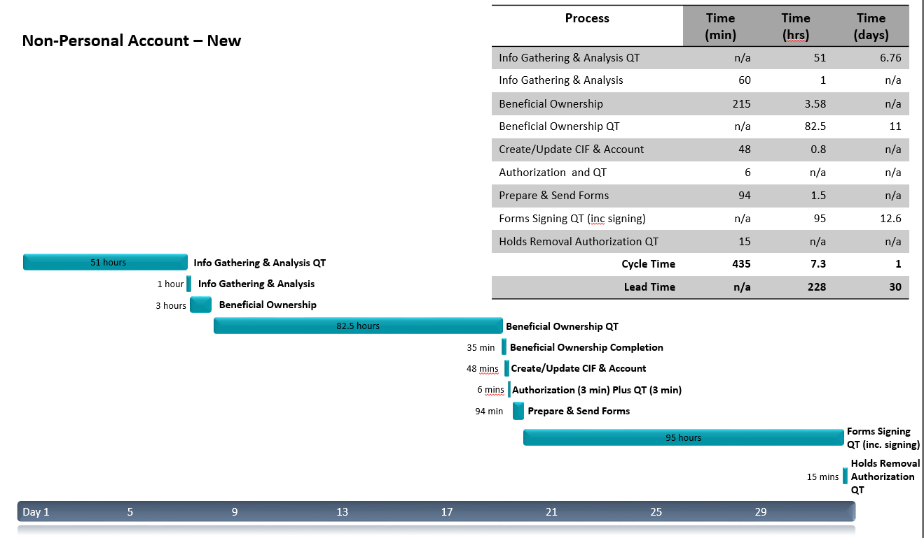
Master review time is not included above; however it was recorded as taking approximately 7 minutes to review a new signer (CIF) on an account. Gathering and input of AML requirements was included in Info Gathering and Analysis, and Create/Update CIF & Account as relevant. The data collected in the time motion study illustrated cycle times approximately 36% lower than what was gathered in self reporting exercises. The queue time was estimated much lower than what was observed during the study; the self reported information was approximately 25% of the queue time recorded during the study.
The majority of the lead time of this process is spent waiting on the client to provide information or sign and return forms - only 3% of the lead time for the transactions captured was working (cycle) time. The queue time varied significantly between transactions, which suggests that this is a client-driven timeline. While the queue times were very different, the cycle times for each process were much more consistent, with the exception of CIF Creation and Account Opening where the times increased with the level of complexity of the client.
Existing data is not shown here as it did not differ significantly from step to step with the exception of Beneficial Ownership, which was much shorter at 40-60 minutes for the transactions observed. This finding should be compared to the pain points that have been expressed at times around the effort required to bring a client record up to the level of completeness required by our current AML requirements.

Observations and Pain Points
The same considerations and constraints applied to observations and pain points for Personal account opening apply for the below noted items.

Observation 1: Authorizations are Ineffective
The same issues identified in Personal account opening apply to Non-Personal. In Edmonton Main, if there is no Cash Management team member available to complete the authorization, the branch employee will request one from the Personal team. The process of placing a hold on an account while waiting for paperwork to be returned was observed for Non-Personal accounts, which added two authorizations to the process.

Observation 2: Our tools and technology are not equipped to mitigate the lengthy lead time and significant queue time inherent in complex business account opening
Details: The most significant factor in the time required to open a business account was queue time, which is largely driven by the client. We do not provide them with tools of convenience to complete their steps in a timely manner; for example digital signature capabilities or a simplified form set.
Impact: The potential reduction in time is difficult to quantify, however any improvements in ease of doing business with CWB would be expected to reduce this queue time and improve the client experience. As a process improvement best practice, work-in-progress should be kept to a minimum as unfinished tasks all require management by the branch employee, which can lead to overprocessing.

Observation 3: The requirements for completing the Beneficial Ownership analysis are unclear. The process requires expertise that cannot be gained with the volumes existing in the branches.
Details: The process of completing a beneficial ownership analysis is time consuming and difficult for many employees to complete. The information required may not be known up front and the branch employee may have to go back to the client multiple times for information. The rules around the use of the Declaration of Beneficial Ownership form (4344) are not specific, although the form is being used at the branch employee’s discretion. Employees at Edmonton Main are engaging the client to complete the form themselves and return to the bank. This process represents a significant amount of the cycle time of the account opening process at nearly half. The requirements for beneficial ownership are continually raised as a source of frustration and confusion by employees, although the AML review process has not shown it to be a significant source of errors.
While the data collected forms the basis of this study, it should be noted that there are additional difficulties faced by BC branches in completing the Beneficial Owner analysis as they do not have the same records available at the provincial registry as other provinces. It is also acknowledged that there may be outliers in cycle time required to complete this information that were not captured here.
Impact: Employees were observed spending a full day intermittently completing the Beneficial Ownership analysis before ‘giving up’ and sending the Declaration form to the client to complete. This represents some measure of wasted time with the end result potentially not delivering the information needed to meet AML compliance requirements. This process represents nearly 50% of the total cycle time of the account opening process, requires multiple client touchpoints (including having them complete a form for the bank against AML guidance) and is a source of confusion and frustration for branch employees.

Observation 4: Forms are numerous and difficult to identify
Details: Of the working time, 22% is spent on preparing and sending forms. Forms must be manually selected based on the transaction and are located in multiple places, including T24, CRA website and InfoServer. As is the case with Personal accounts, Non-Personal require a minimum of six forms, four of which require populating, and may represent overproduction of required information if the same data is entered multiple times. If cash management products are also provided at the time of account opening, each incremental product requires a form, although this requirement will be reduced significantly with the rollout of COMET forms consolidation in September 2019.
Impact: Each form requires time and effort to complete. Any non value added or repetitive information (or form) adds cycle time and introduces opportunity for error. While there were no errors in returned forms observed during the time motion study, the delay created by an error for Non-Personal account opening could be quite significant due to the extended queue times.

Pain Points:
As is the case for personal account opening pain points, some of these may reflect opportunities to promote awareness of the necessity of certain process requirements.
- The need for ID verification is understood, however the cost of staff time and client time to complete this task is seen as excessive.
- Edmonton Main has been completing the RC518 Declaration of Tax Residence form with the client as part of the account opening package, but this form is also sent out centrally by Regulatory Compliance for all eligible account opening activity. This raises the likelihood of form completion, but creates a poor client experience as they receive the form twice and may complete it twice. Edmonton Main has requested RC to stop sending the form to their clients. The form is also occasionally missed as it must be pulled separately from the CRA site.

Opportunities
As was noted for Personal account opening, these opportunities are focused on the objective of process improvement and are reflective of the process as observed at Edmonton Main during the period of the time motion study.
Opportunity | Process Step | Time Savings per Transaction | Total Time Savings (7hr day, based on 2018 volume)
There is no evidence that the current authorizations process reduces errors or increases AML compliance. Removing the authorization required to open a demand account and solidifying the Master Review process without expanding the time spent would eliminate an entire step. | Authorization | 3 min | Demand: 34 days/year or 0.13 FTE
The number and structure of required forms should be reviewed for consolidation and reduction opportunities. Optimization of flow and transaction-based auto-selection of required form(s) should be considered.  *resources required to revise forms have often been highly constrained at CWB due to backlog | Prepare and Send Forms | Demand: 47 min (hypothetical 50% reduction in prep time) | Demand: 528 days/yr or 2.1 FTE  Investment: not captured
Consolidate Beneficial Ownership analysis and documentation to a small group who are dedicated primarily to this task and can develop expertise, efficiency and best practices. | Beneficial Ownership | Reduce from 215 min to 161 (hypothetical 25% reduction) | Demand: 279 days or 3.3 FTE  Investment: 92 days or 0.4 FTE  Credit: 51 days or 0.2 FTE  Remaining work – approx. 4 FTE
*based on transactional volume 2018 across all branches

Account Opening Current State Assessment and Self Reported Data Gathering (Delivered April 2019)

Executive Summary
The purpose of the Account Opening current state assessment is to gain a deeper understanding of the process performance and pain points experienced by our staff and clients for each client type – Personal and Business – and account category – Demand, Investment, and Credit. This is intended to provide objective analysis of the current state, including comparisons across the different categories to understand the key differences and their impact.
While each account category and client type is reviewed individually, a number of key themes have emerged:
- There are a number of similarities between Demand and Investment account opening in terms of lead time and allocation of time spent on activities.
- For Personal Demand and Investment account opening, the majority of the process lead time is spent in activity, rather than waiting.
- The lead time for Personal Demand and Investment account opening is low, even as executed more efficiently by Motive.
- For all other account opening processes (Business Demand and Investment, Credit), the majority of the process lead time is spent in waiting, rather than activity. This may reduce the effectiveness of streamlining activities such as forms redesign on lead time, although they may have an impact on error rates and staff engagement.
- AML and audit activities represent the highest allocation of effort in demand account opening.
- There is no correlation between AML deficiency rates and branch account opening volume.
These findings suggest that while targeted efforts could be made to streamline or simplify some steps, the impact on the overall process would not provide the benefit required to transform the process. This affords us opportunities to consider innovating our approach to account opening externally, through the use of digital tools and platforms, and internally, through a different structure to support the process.
The time estimates contained within the document are self reports, and are subject to inaccuracy. Validation of the self reports will be undertaken through a brief Time Motion Study to observe and analyze actual cycle time and lead time for each account type and client type.

Approach
In order to gather information and pain points, a number of workshops and group and individual interviews were conducted on Personal and Business account opening throughout March 2018. This effort included 46 participants, from Retail, Commercial, Cash Management, Motive, and Credit Support, and also included representation from Real Estate, EFG, Corporate Lending, and Virtual branch, pertaining to Demand and Investment account opening, and the Anti-Money Laundering (‘AML’) and Know Your Client (‘KYC’) aspects of opening a Credit account. Volumes from Information Management for all new account openings on the 3 product groups - Demand, Investment, and Credit - were obtained and analyzed for the period of November 2017 to February 2019.
An overview of the three categories of Account Opening included in this analysis is provided below, with the high-level tasks identified.
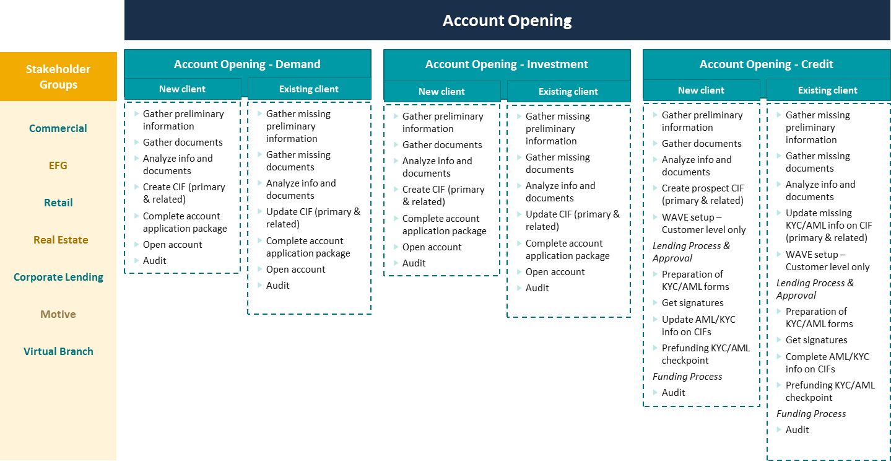

In addition, self-reported information was also gathered on other process flow measures to quantify the time to conduct various activities:
- Lead Time: total time required for delivery of a product or service, from the first activity through completion. Time the client is required to wait for a product or service.
- Cycle Time: time to complete one unit of work or one process step within the delivery of a process step
- Queue Time: time between units of work or process step. During queue time, no work is being done – the product or service is waiting for the next step to commence.
Lead Time
Queue Time
Create/ Update CIF
Open Account
Prepare & Print Forms
Submit for Audit
Gather Information
Cycle Time

Through these efforts, a total of 74 pain points were captured and summarized. A discussion of the pain points identified for each process category is provided within the relevant section.
For this analysis, the following definitions were applied:
- New Customer - No previous personal or business Customer Information File (‘CIF’) available. For example, a new referral to CWB requiring a new account opening.
- Existing Customer – Previous personal or business Customer Information File (‘CIF’) available within and prior to the respective calendar year, and often with existing Demand, Investment, and/or Credit facilities. For example, an existing client with a chequing account requesting a new term deposit and term loan accounts.
It is important to note that the pain points and self-reported timings gathered are based on the perception of the respondent. While this is an excellent indicator of the mindset of those performing the process, they reflect a set of feelings and viewpoints and not facts. As such, certain limitations should be understood when reviewing them:
- Pain points expressed may be based on a recent or particularly painful experience rather than the common experience.
- Pain points may reflect a misuderstanding of policy, documented procedure, or system function. They may be factually incorrect or based on the wrong premise.
- Pain points often reflect the symptom, not the cause. Those expressing pain points are articulating the impact.
- Self-reported process timings may be based on a recent or difficult experience rather than the common process performance.
- As measurement is not taking place during the process performance, self-reported process timings carry a number of biases, including:
  - Telescoping – lengthening the recall period beyond the timeframe in question, or reverse telescoping
  - Extended recall period leading to memory decay

Demand Account Opening

Personal

Process and Pain Points
Personal account opening is generally the domain of Retail, although in some branches the process is supported by Cash Management. An overview of the process is below:
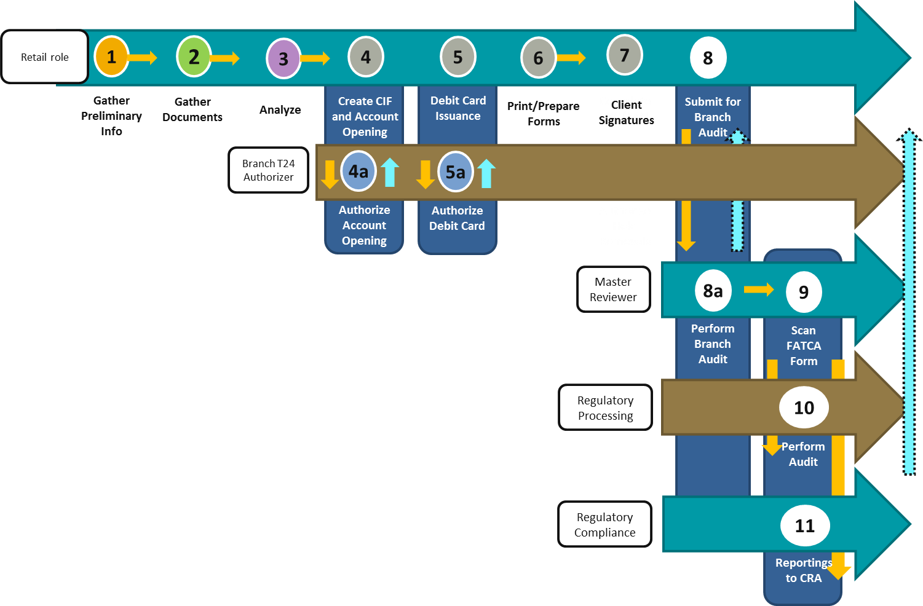
Even at this level of detail, a couple of patterns emerge:
- There are concurrent but standalone authorizations required. Pain points expressed frustration with the impact of the authorizations on client experience, as they are required in real-time.
- There are multiple audits being performed by different groups. Despite this, defects are still found in the AML Regulatory Processing audit in step 10.

Process Pain Points
In addition, interviewees were frustrated with the time, steps, and information needed to open a new account for an existing client, where the majority of AML requirements were either outdated or not on file and in need of collection. When new requirements for FATCA and CRS (forms RC518 and RC519) came into effect on July.1, 2017, it created a need to collect additional information for existing clients, which can feel burdensome.
Two processes exist for getting the FATCA form RC519 signed. If Regulatory Compliance does not receive a scanned & signed RC519 from the branch within 24 hrs of account authorization, they will send the form to the client for signing directly. This often confuses the client and the branch.

System and Artifacts Pain Points
There were also a number of points raised around T24 and forms:
- Forms must be retrieved from a number of sources: T24, CRA website, InfoServer, Equifax.
- Must populate non-T24 forms manually.
- Missing required data fields on official bank forms, like the Personal Financial Statement and Declaration of Beneficial Ownership form #4344.
- If account application forms from T24 are printed out but authorized over month end, the account number listed on the signed form would change. This has led to a workaround where accounts are opened but have a hold placed on them until the signed documents are returned, which preserves the account number but requires additional authorizations to undo.
- No validation or error-proofing of T24 data entry.
- Navigation between the required screens in T24 is cumbersome.

Lead Time
Based on the estimates provided in the interviews, the time to set up a new account, including CIF setup (for a new client) or CIF review and verification against AML requirements (for an existing client), ranges from just over an hour for an existing single-CIF client to 2.6 hours for a new, many-CIF client.
 | Client Type |  | Single CIF |  |  |  | 2 CIFs |  |  |  | 4 CIFs
 |  | Lead Time |  | % of time in queue |  | Lead Time |  | % of time in queue |  | Lead Time |  | % of time in queue
 | New |  | 1.7 hours |  | 11% |  | 2.1 hours |  | 10% |  | 2.6 hours |  | 8%
 | Existing |  | 1.1 hours |  | 0% |  | 1.4 hours |  | 0% |  | 1.6 hours |  | 0%

Key Findings
- As the number of CIFs increase, the amount of incremental time required decreases. This suggests possible efficiency or experience gains when completing the process multiple times.
- There is also very little time spent in queue. This reflects the real-time or near real-time nature of the process, and should be considered in light of the client experience provided.

Step | Category | High-Level Tasks | % of Lead Time
Step | Category | High-Level Tasks | New | Existing
1 | Information Gathering | -Fircosoft checks  -Basic client information  -Intended use  -US persons  -Politically Exposed Foreign Persons (PEFP/PEP)  -Check WAVE or existing account opening file, if existing client  -Includes reviewing existing account opening file and T24 for missing/outdated information to obtain | 9% | 24%
4 | Create/Update CIF, Account Opening, Debit card issuance | -T24 inputs to open up each CIFs for primary and related parties  -Collection and inputs of all KYC/AML field requirements  -Open demand product(s) on T24  -Issuance of debit cards on T24 | 13% | 15%
5
6 | Print/Prepare forms & gather client signatures | -Print account application form #4042 off T24  -Fill in and print RC518 form, if applicable  -Print debit card form #4007 (new card) or #4246 (update card) off T24  -Special signing authority form #4341, if applicable  - gather client signatures | 22% | 0%
7
8 | Submit for Branch Audit | -Do PIN changes on the debit card with the client  -Photocopy the signature card  -Notes and commentaries on T24  -Send client the Account Consent Letter, when acting on verbal instructions for existing clients | 9% | 19%
8a, 9 | Branch Audit/Scanning | -Audit off the Master Review Report for each account opened against T24 and paper file  -Sign off on form #4325  -Upload signature card via ACME for Doxim  -Scan FATCA form #RC518 to Regulatory Compliance | 28% | 39%

Differences Between New and Existing
The table above illustrates the proportion of time spent on each activity. As two CIFs is a common scenario for personal demand accounts, the information provided for this scenario has been applied. The most significant differences between new and existing cycle times are easily identified:
- Step 1 – Information Gathering, which self-reporting indicated takes nearly three times as long for existing clients. This is reflected in the pain points.
- Step 6/7 – Forms and signatures. As there are additional forms required for new clients, this result is expected.
- Step 8 – Submit for Branch Audit. It is unclear why this amount would differ, although this may be due to the self-reported nature of the data, which allocates 1/3 of the total time required to this step.

Volume
The majority of demand account opening volume is Personal, at 63% of new to bank clients and 75% of existing. Their openings are also fairly evenly distributed among the 3 regions: Prairies, Northern Alberta, and BC.
Region | New to Bank | % of total New | Existing | % of total Existing
Prairies | 999 | 27% | 2091 | 28%
Northern Alberta | 1408 | 38% | 2315 | 31%
BC | 979 | 26% | 2126 | 28%
EFG | 1 | 0% | 11 | 0%
Real Estate | 0 | 0% | 6 | 0%
Motive | 311 | 8% | 969 | 13%
Total | 3698 |  | 7518

Top 5 Branches – Personal Demand Account Opening Volume | # of accounts | % of total
Motive | 1280 | 11.4%
Edmonton 103rd Street | 778 | 6.7%
Edmonton Main | 516 | 4.6%
South Edmonton Common | 411 | 3.7%
Nanaimo | 387 | 3.4%

The volume of the top five branches is listed above. Setting aside Motive, which is discussed in detail below, the rest of the top five amounts to less than 20% of the total personal demand accounts opened. This illustrates a scattered distribution of activity among branches – even at the high end of 778 through 2018, this represents less than three Personal accounts opened at Edmonton 103rd each day, some of which may be employee accounts driven by the proximity to Corporate office.

Personal – Motive

Motive Account Opening
Motive is a division of Canadian Western Bank and primarily serves to meet the needs of a remote client base, including geographical areas that do not have CWB branches. It operates exclusively online, with dedicated agents who provide client support by phone. Its strategic positioning aligns well with CWB’s corporate objectives of balanced growth and franchising clients, while continuing to support the expansion into Eastern Canada.
Motive’s product offerings are comprised of personal demand and investment accounts only, including daily chequing, high interest savings, GICs, RRSPs and TFSAs. As noted above, Motive takes the lead in opening up more personal demand accounts than any other branch. For this reason, their process and business model were captured in order to summarize their core differences from in-branch account openings. The goal to include Motive in this Account Opening current state report is to understand the differences, and where best practices can be adopted in future state designs.
Motive receives an average of 40 new online account opening requests/day. These are predominantly for non-registered savings accounts. They have 17 internet banking agents in total, 7 of which are dedicated to account opening while the other 10 focus on the operational maintenance of these accounts, including acting as call centre agents.
Each account opening specialist can open up 10 - 12 accounts in one day, provided all the information is available. Assuming a 7 hour work day, this is equivalent to spending 35 - 42 minutes, or 0.58 - 0.7 hours on each personal account opening. This can be compared with the self reported numbers of 1.5 - 2.4 hours on an in-branch personal demand account opening and 1.5 - 2 hours on an in-branch personal investment account opening.
Motive’s largest pain point is the absence of validation logic in the online application form filled out by the client. Hence, in the past, 70% of the account opening applications received would require clarification or followup with the client. This significantly increased the queue time of the account opening process and often led to application abandonment. Motive is currently exploring automation opportunities such as robotic process automation (RPA) to support various aspects of the account opening process.

Below is a summary of the key process differences between the branch process and Motive.
Category | Branch | Motive
Gather Preliminary Information | In person branch only | Online application submission only
Gather Preliminary Information | Consent to Obtain Financial Information form #4325 required before pulling credit bureaus. | No separate Consent to Obtain Financial Information form #4325 needed to pull credit bureaus. Clause embedded into the online application form.
Gather Preliminary Information | Branch does not complete a manual check against Regulatory Compliance list of unwanted addresses | Cross reference applicant’s address against a list from Regulatory Compliance to screen out unwanted addresses, aka Mail drop search
Gather Preliminary Information | Viewing and input of IDs required in T24 | No viewing of IDs required. User will input ID1 as 3 year history and ID2 as Exempt in T24
Gather Documents | Paper documents and file with no front end digital account opening repository system. | No paper at all. All client notes and PDF credit bureau/client application form are stored digitally on OneNote, before uploading into Filenet as the final repository
Gather Documents | Gathering FATCA form RC518 must be signed and scanned to Regulatory Compliance within 24 hrs of Account Authorization. | Gathering FATCA form RC518 is on a best attempt basis only. Soft requirement. Will do a mailout to the client to sign and return.
Analyze | KYC and AML clarification with the client is in-person or over the phone | Any KYC and AML clarification with the client is via electronic means only
Analyze | Main checkpoint on the Credit Bureaus are the beacon scores | KYC/AML is heavily relied upon the Credit Bureau information matching exactly against the information provided by the client in the application form.
Create CIF and Account Opening | Multiple application forms from different sources to print and have signed | No client forms to print and sign
Branch Audit | Paper print out of the Master Review Report | No paper print out of the Master Review Report
Branch Audit | Wet ink signoff | Digital signoff from Adobe on the report and saved in Filenet
The lead time differences between Motive and the branch processes are compelling, and it is likely that some of the variance can be explained by the divergent process requirements. Some, such as digital signoff used by Motive, can be applied to the branch process as a best practice, but as the audit step was not a significant proportion of account opening, may not make an impact on the lead time and, as it applies to the post-client interaction, would not have an impact on client experience. Others, such as the KYC/AML clarification process, may be faster from a cycle time perspective, but due to the stringent nature of the validation process used by Motive may offer less flexibility for the client, and may be a contributing factor to the application abandonment issue noted above. Opportunities for Motive to provide an alternative to in-branch account opening should also be explored.

Business

Process and Pain Points
The range of complexity for a Business (non-personal) account is significant and directly reflective of the type of business the account is being opened for. A sole proprietor will experience a process similar to a personal account. An account opened for a Lawyer/Real Estate trust will involve many people from the client side, and can span weeks.
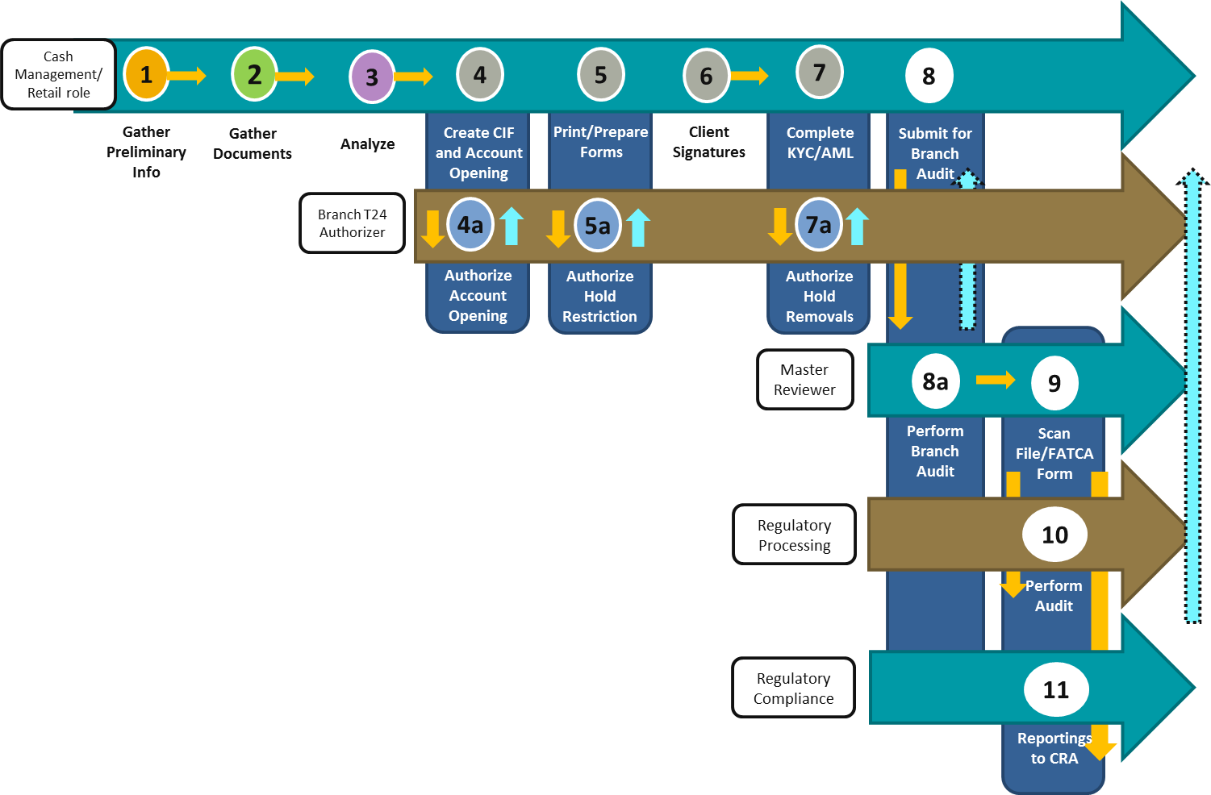
*does not include debit card issuance and associated T24 authorization
The process as depicted has the same number of process steps as Personal, and flows similarly, although the magnitude of some of the tasks may be much more significant. For example, Step 3 – Analyze is much more complex as it requires research and validation of the ownership structure of a company.
The pain points that exist for Business Demand account opening are similar to Personal, although the added complexity and lead time may make them more acute. Additional pain points are listed below:
- Branch T24 authorizers and post account opening Master Reviewers are often retail roles with inconsistent knowledge and experience to approve/audit complex business account openings.
- A standardized mandate or follow up for branches to remediate deficiencies noted by Regulatory Processing team does not exist.
- Account openers often do not know what AML/KYC requirements are needed in both the paper file & T24 system inputs (for new and existing CIFs), nor understand the rationale of the requirements. This is especially pronounced for specialized (corporate, syndicated, and real estate) lending when agent banks are involved. They also do not know where or who to obtain clarity from.

Lead Time
Self-reported cycle times were provided based on client complexity, although in the case of Non-Personal the complexity refers to the type of business rather than the number of CIFs:
- Low – Sole proprietor
- Medium – Corporations including charities, condo and strata corporations
- High - Partnerships including lawyers/real estate trusts, trusts, joint ventures, associations, and trade and labour unions
Lead time for Non-Personal is calculated in days, not hours.
Client Type | Low Complexity |  | Medium Complexity |  | High Complexity
 | Lead Time | % of time in queue | Lead Time | % of time in queue | Lead Time | % of time in queue
New | 4.7 days | 89% | 9.8 days | 83% | 15.1 days | 80%
Existing | 4.5 days | 89% | 8.7 days | 80% | 13.1 days | 77%

Step | Category | High-Level Tasks | % of Total Cycle Time
Step | Category | High-Level Tasks | New | Existing
1 | Information Gathering | -Fircosoft checks  -Basic client information  -Intended use  -Government registries  -System for Electronic Document Analysis and Retrieval (SEDAR) check for ownership information  -US persons  -Politically Exposed Foreign Persons (PEFP/PEP)  -Google searches on company  -Details of company  -Check WAVE or existing account opening file, if existing client  -Includes reviewing existing account opening file and T24 for missing/outdated information to obtain | 16% | 15%
2 | Document Gathering | -Signed consent form #4325  -Pull credit bureaus  -Financial statements  -Corporate searches  -Central Securities Register/Share Register  -PEP/PEFP form #4193, if applicable  -Documents related to the specific legal entity type of company  -Check WAVE or existing account opening file, if existing client | 16% | 15%
3 | Analysis | -Full analysis of information and documents received  -CWB Declaration of Beneficial Ownership form #4344, if applicable  -Beneficial ownership structure of company | 23% | 23%
4 | KYC/AML on CIF creation/update on T24  Account Opening | -T24 inputs to open up each CIFs for all ownership %’s  -Collection and inputs of all KYC/AML field requirements  -Open demand product(s) on T24  -Notes/commentaries in T24 | 28% | 36%
7
8a, 9 | Branch Audit/Scanning | -Audit off the Master Review Report for each account opened against T24 and paper file  -Sign off on form #4325  -Upload signature card via ACME for Doxim  -Scan FATCA form #RC519 to Regulatory Compliance  -Scan full account opening paperwork to Regulatory Processing (for business only) | 11% | 11%
As is clear from this summary, the main difference in lead time between new and existing is related to the KYC/AML on CIF creation/update step. However, as the self-reported data shows longer lead times for new than existing clients, the additional time spent may not be a significant process driver. It does, however, reflect the challenges and pain points expressed around opening accounts for existing clients across account types and groups (Personal and Business).

Volume
The table below shows the number of new Business demand accounts opened for 2018, broken out by the Regions. EFG, Real Estate, and Motive have been extracted out as standalone business lines on a national level.
Regional Breakdown | # of New Accounts Opened for New: | % | # of New Accounts Opened for Existing: | %
Prairies | 446 | 21% | 627 | 25%
Northern Alberta | 442 | 20% | 516 | 20%
BC | 957 | 44% | 1085 | 43%
EFG | 29 | 1% | 76 | 3%
Real Estate | 299 | 14% | 239 | 9%
Motive | 0 | 0% | 0 | 0%
Total | 2173 |  | 2543
Again, the proportion of new and existing is consistent within each region. The number of accounts opened for existing clients is not much larger than for new.
Top 5 branches – Business Demand Account Volume | # of New Accounts | % of total
Park Place | 441 |  | 9.3%
Strawberry Hill | 243 |  | 5.2%
Edmonton Main | 234 |  | 5.0%
Calgary Main | 227 |  | 4.8%
Vancouver Real Estate | 219 |  | 4.6%

These top five branches (Park Place, Strawberry Hill, Edmonton Main, Calgary Main, and Vancouver Real Estate) collectively opened up about 30% of all business demand account openings across the Bank.

Investment Account Opening

Personal

Process and Pain Points
The process of opening a personal investment account is similar to that of a personal demand account at the level described below. However, within the procedures there are some differences.
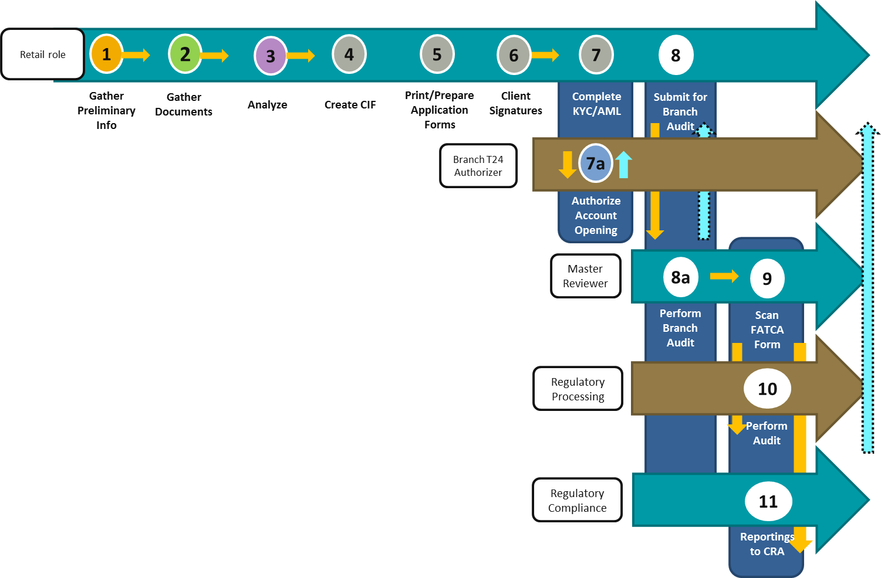
Category | Demand Account Opening | Investment Account Opening
Gather Documents | Credit bureaus are pulled at time of new account opening | No credit bureau pulls are required
Account Opening / Print and Prepare Forms | Forms are printed off and pre-filled from T24. | Forms are standalone from InfoServer. Requires complete manual population.
Account Opening / Print and Prepare Forms | No certificates are printed off of T24. | Non-registered GIC certificates are manually printed off of T24 after system authorization is provided to provide to client, along with other CDIC brochures.
Account Opening / Print and Prepare Forms | Debit card issuance can be included as part of opening up a demand account (especially on personal) | Typically no debit card issuance
Print and Prepare Forms / Branch Audit/Scanning | Signature cards are signed and sent for DOXIM uploads | No signature cards required
T24 Authorizations | Authorizations for account openings occur before clients sign the forms | Authorizations for account openings occur after clients sign the forms

Pain points provided were consistent with demand account opening, although as forms are not generated from T24 this was not an issue.

Lead Time
Client Type | Low Complexity |  | Medium Complexity |  | High Complexity
 | Lead Time | % of time in queue | Lead Time | % of time in queue | Lead Time | % of time in queue
New | 1.7 hours | 11% | 2.0 hours | 10% | 2.3 hours | 13%
Existing | 1.0 hours | 0% | 1.2 hours | 0% | 1.4 hours | 0%

The lead times that were self-reported during the interviews are listed below, and do not differ significantly from what was gathered for Personal Demand accounts – the times range from identical (New – Low complexity) to 15% less (Existing – Medium) than Demand account opening, although that 15% represents only a difference of twelve minutes. As the lead times for each account type are so similar, it is likely that the process differences offset each other.
Queue time is similar for Personal Investment accounts as for Personal Demand. Again, this suggests that much of the process is happening in real-time, which has implications for client experience that should be explored.
The same labour intensive parts of opening up a personal investment accounts were identified as for a Personal Demand account, with the exception of the preparation of application forms. As investment forms are standalone on InfoServer and need to be completely pre-filled manually (versus partially-prefilled and printed off T24), it takes 5 - 10 min longer to perform this function as compared to opening up a Personal Demand account.
This process does not have the debit card issuance step. By not needing to issue a debit card on a personal investment account, not only does it remove the printing and signing of debit card form #4007 (or form #4246 update), it also removes the tasks of a) linking it as a new product on T24, b) needing account authorization on the debit card product, and c) escorting the client to a station to do a PIN change on the card.

Volume
Almost all investment account openings for New and Existing clients are personal, at 78% and 93%, respectively. Their openings are also fairly evenly distributed among the regions: Prairies, Northern Alberta, and BC.
Regional Breakdown | # of New Accounts Opened for New: | % | # of New Accounts Opened for Existing: | %
Prairies | 268 | 32% | 9929 | 30%
Northern Alberta | 271 | 32% | 11951 | 36%
BC | 236 | 28% | 8924 | 27%
EFG | 2 | 0% | 7 | 0%
Real Estate | 1 | 0% | 6 | 0%
Motive | 60 | 7% | 0 | 0%
Total | 838 |  | 32760

The number of new Personal Investment accounts opened for Existing clients is 40 times that for New clients (32,760 investment sub-accounts versus 838 investment accounts for new-to-bank clients).
Top 5 branches – Personal Investment Account Opening | # of New Accounts Opened for New & Existing clients | %
Motive | 2003 | 6.0%
Edmonton Main | 1766 | 5.3%
Regina | 1658 | 4.9%
Edmonton 103rd Street | 1598 | 4.8%
Edmonton Old Strathcona | 1564 | 4.7%
Similar to Personal Demand accounts, the share of Personal Investment account opening completed by any one branch is higher in the above branches, but is distributed among the branch network.

Business

Process and Pain Points
The process as depicted has the same number of process steps as Personal, and flows similarly, although it may involve different resources as it is supported by Cash Management in some branches.
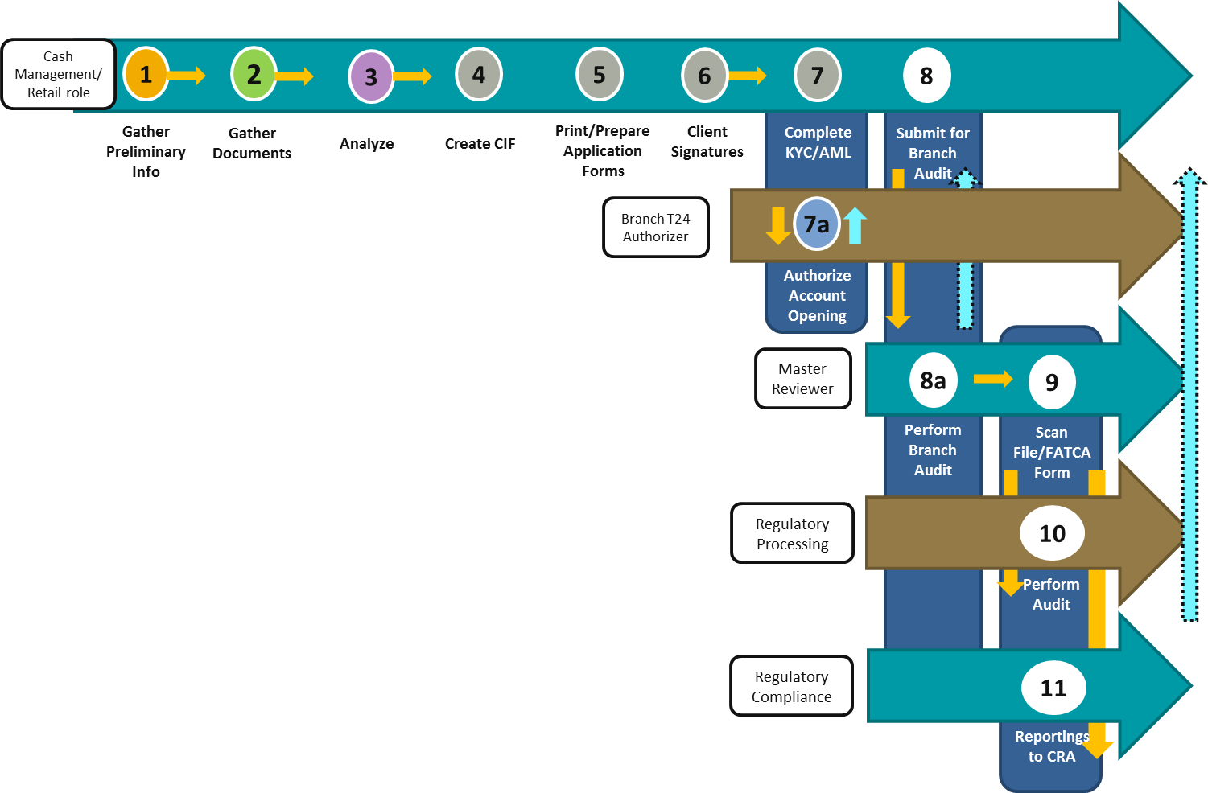
Pain points did not differ significantly from Business Demand account opening.

Lead Time
The lead times for each level of complexity are shown above based on self-reported data.
Client Type | Low Complexity |  | Medium Complexity |  | High Complexity
 | Lead Time | % of time in queue | Lead Time | % of time in queue | Lead Time | % of time in queue
New | 4.5 days | 91% | 9.8 days | 83% | 15.0 days | 80%
Existing | 4.5 days | 89% | 8.8 days | 80% | 13.1 days | 76%
While at the highest level of complexity there is some difference between the time required for a New and an Existing client, this may be due to the onboarding and orientation activities that new clients require. There is no meaningful differentiation in lead time. Much of the lead time can be attributed to the queue time, which represents the time in which CWB is waiting on the client to complete a task. The proportion of time in queue, where the client is generally in control of the process, is consistent across all levels of complexity and is very similar to Demand business account opening.
The same top five labour intensive aspects of opening up a Business Investment account are the same as opening up a Business Demand account, although as the majority of the lead time is spent in queue, this is not a significant contributor to the lead time.
One thing to note is the time required to complete the forms for opening up a Business Investment account. Because forms are standalone on InfoServer and need to be completely pre-filled manually (versus partially-prefilled and printed off T24), it takes 30-45 min longer to perform this function as compared to opening up a business demand account.

Volume
Regional Breakdown of Existing customers | # of New Accounts Opened for New: | % | # of New Accounts Opened for Existing: | %
Prairies | 46 | 19% | 617 | 26%
Northern Alberta | 55 | 23% | 718 | 30%
BC | 54 | 23% | 551 | 23%
EFG | 5 | 2% | 51 | 2%
Real Estate | 79 | 33% | 416 | 18%
Motive | 0 | 0% | 9 | 0%
Total | 239 |  | 2362

The number of new business investment sub-accounts opened for Existing clients is 10 times that for New clients (2362 investment sub-accounts versus 239 investment accounts for new-to-bank clients). Real Estate takes the lead in opening up investment business accounts for New-to-bank clients at 33%.
Top 5 branches – Business Investment Account Opening | # of New Accounts Opened for New & Existing clients | %
Coquitlam | 327 | 12.5%
South Edmonton Common | 170 | 6.5%
Edmonton Main | 154 | 5.9%
Edmonton 103rd Street | 133 | 5.1%
Vancouver Real Estate | 131 | 5.0%
Similar to Business Demand account opening, Business Investment account opening is more concentrated among the top branches than for personal, with the top five holding 35% of activity. However, the volumes are much lower.

Credit Account Opening
While the process overview below captures the life cycle of a new credit account (i.e., funding of a loan), the scope of Credit Account Opening in this report focuses only on the Know Your Client (‘KYC’) and Anti-Money Laundering (‘AML’) portions of opening or completing the CIF. This portion is identical to that for Demand and Investment account opening but relates to a loan facility.
To mirror the same scope of gathering processing times and pain points on AML and KYC tasks as the demand and investment account openings, only Steps 1-4 and 6, as it pertains to KYC and AML, were investigated. Processing times and pain points on the rest of the credit process – Pre-Qualification, Origination, Adjudication, and Funding will be captured as part of the end-to-end Business Process Review Program. Likewise, any information & document gathering and analysis on the credit’s collateral are out of scope.

Process and Pain Points
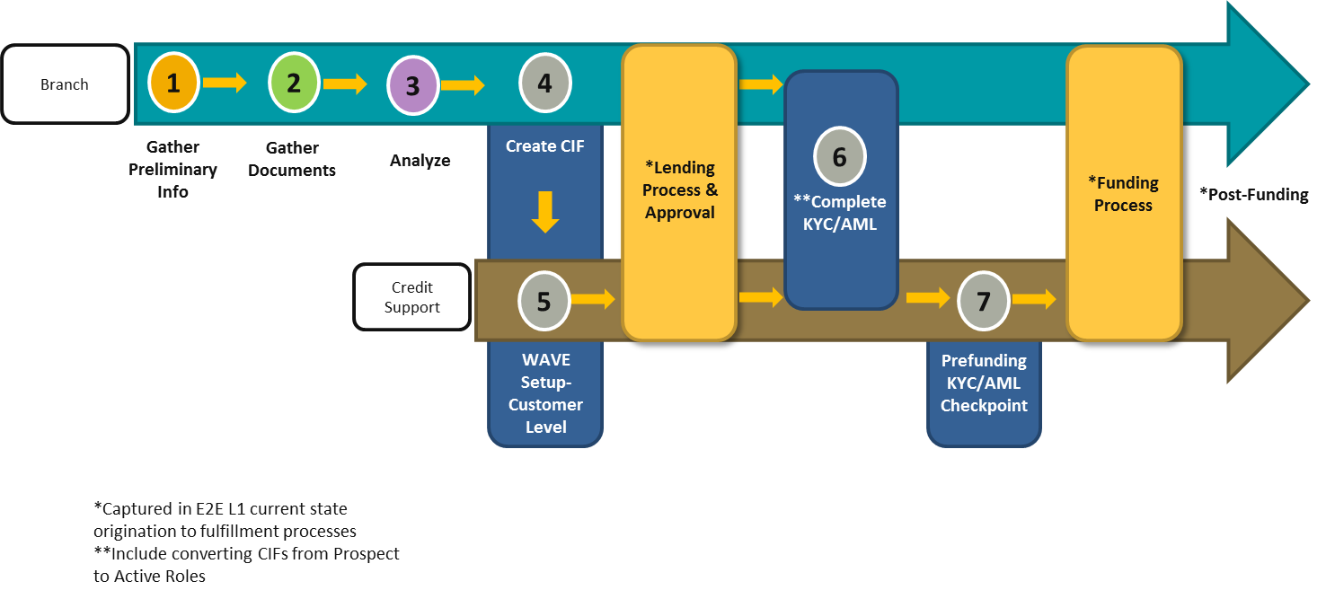
The process above is relevant to both Personal and Business Credit account opening. The tasks within each process step are similar to Demand and Investment with the exception of the interactions with WAVE, CWB’s loan origination system. As some of the information is input into WAVE and pushed to T24 via an API, additional steps and checks are introduced (noted in italics):

Step | Category | High-Level Tasks
4 | KYC/AML on CIF creation/update on T24  Account Opening | -T24 inputs to open up each CIFs for all ownership %’s  -Collection and inputs of all KYC/AML field requirements  -Notes/commentaries in T24  -Convert CIFs from prospect to active roles
6 | KYC/AML on CIF creation/update on T24  Account Opening
5 | WAVE Setup – Customer Level | -Credit Support set up customer in WAVE by entering in information that didn’t get pushed from T24. Authorization is required, but is related to the loan rather than the account setup.
7 | Prefunding KYC/AML Checkpoint | -Checking of T24 and WAVE to ensure all KYC/AML information and documents have been received before forwarding the deal for disbursements. IF the CIF has not been converted from prospect to active, this is a system hard stop on funding that must be remediated.

While there was overlap with Demand and Investment, there were unique pain points expressed for Credit account opening, surrounding role accountability:
- Roles and policies are siloed when overlapping products are opened, leading to duplicate steps, employee frustration, and/or poor client experience. For example, a line of credit requires a demand account to be opened. Clients must sign a Personal Financial Statement (‘PFS’) for a credit bureau pull in WAVE with the lending sales team and a Consent to obtain financials form #4325 for a 2nd credit bureau pull with the account opening team.
- Business Credit accounts have a noteworthy issue on the Who, What, and How when it comes to the collection and input of AML (PEP, PEFP, US persons) in T24. There is confusion over the involvement of Cash Management, the knowledge base of commercial teams required to serve this function, and the responsibilities of Credit Support. The issue is especially pronounced for Credit Business accounts.
There has been some activity related to the latter point, with a recommendation pending to Operations Committee (as of May 1, 2019) to mandate the opening of an operating (Demand) account for every loan as is standard industry practice. This recommendation, if accepted, would create the potential to subsume the role accountabilities of opening a Credit account with that of the Demand account.

Lead Time
The two tables below display the anecdotal estimated Lead times gathered from one-on-one interviews on steps 1 - 4 and 6. Because the credit interviews captured information at a less granular level than the demand and investment interviews, the responses did not break down the cycle time and queue time, although based on information collected for other account types it is possible to presume that Gather Info and Documents does have some client involvement and some waiting (queue) time, and that the timing is aligned with factors within the lending process. The time that can be attributed to a particular process step generally aligns with the corresponding steps for Demand and Investment account openings.

PERSONAL Client | Complexity | Gather Info & Documents  (Steps 1-3) | System Data Entry  (Step 4) | Complete KYC/AML  (Step 6) | Total
New/Existing | 1 CIF | 1 hour | 5 mins | 3 mins | 1.13 hours
New/Existing | 4+ CIFs | 10 days | 45 mins | 30 mins | 76.25 hours

BUSINESS Client | Complexity | Gather Info & Documents  (Steps 1-3) | System Data Entry  (Step 4) | Complete KYC/AML  (Step 6) | Total
New | Low | 2 days | 2 mins | 5 mins | 2.00 days
New | Med | 15 days | 30 min | 15 mins | 15.01 days
New | High | 45 days | 60 min | 60 min | 45.1 days
Existing | Low | 15 min | 2 min | 5 min | 0.07 days
Existing | Med | 15 days | 30 min | 15 min | 15.01 days
Existing | High | 35 days | 60 min | 60 min | 35.1 days
No difference between New and Existing clients was reported for Personal. Only at the highest level of complexity was there a difference reported between New and Existing for Business.

Volume
Regional Breakdown of New-to-bank customers | # of New Accounts Opened for New: | % | # of New Accounts Opened for Existing: | %
Prairies | 48 | 44% | 741 | 31%
Northern Alberta | 14 | 13% | 804 | 34%
BC | 31 | 29% | 759 | 32%
EFG | 15 | 14% | 78 | 3%
Real Estate | 0 | 0% | 3 | 0%
Total | 108 |  | 2387
Note: There are new personal accounts opened under EFG for New-to-bank clients and Existing clients, 14% and 3% respectively. After an analysis of the data, we have confirmed that they are indeed sole proprietor business loan accounts and were coded incorrectly during funding.

Regional Breakdown of Existing customers | # of New Accounts Opened for: | % | # of New Accounts Opened for Existing: | %
Prairies | 14 | 11% | 597 | 12%
Northern Alberta | 13 | 10% | 1142 | 22%
BC | 37 | 28% | 1162 | 23%
EFG | 65 | 49% | 1649 | 32%
Real Estate | 4 | 3% | 582 | 11%
Total | 133 |  | 5132

EFG group takes the lead in opening up credit business accounts for New-to-bank clients and Existing clients, at 49% and 32%, respectively. This illustrates the fact that the volume of credit accounts is a direct reflection of lending activity. The difference between New and Existing is a function of repeat lending business.

Regulatory Processing AML Audit
Centralized Regulatory Processing team performs post account opening audit on both personal and business accounts opened. The data currently available does not allow for breakdown between Demand, Investment, and Credit.
For personal CIFs, they review a) 100% of T24 inputs, including those opened by Virtual Branch, Deposit Processing Centre (DPC), and Motive, and b) random 30% of paper documents.
For non-personal CIFs, they review a) 100% of T24 inputs and b) random 30% of paper documents on Filenet (electronic document storage and retention system).
The below table shows the percentage of customers audited that are found to have a minimum of one deficiency requiring branch remediation. These numbers are based on each customer’s T24 profile and not reflective of the role of the staff opening up the account, or the type of account. For example, one new Business account opening performed by a branch’s Cash Management or Retail staff will have one non-personal CIF along with a (or multiple of) personal CIF(s) related to that business entity.
 | Personal CIFs |  |  | Non-Personal CIFs
Month | Total CIFs reviewed | CIFs with min 1 deficiency | Percentage | Total CIFs reviewed | CIFs with min 1 deficiency | Percentage
Feb-19 | 2164 | 582 | 26.89% | 1046 | 216 | 20.65%
Jan-19 | 3029 | 865 | 28.56% | 1472 | 219 | 14.88%
Dec-18 | 1935 | 637 | 32.92% | 1360 | 219 | 16.10%
Nov-18 | 2727 | 913 | 33.48% | 1609 | 270 | 16.78%
Average |  |  | 30.46% |  |  | 17.10%
When an account is opened for a new and/or existing client passes the audit controls in the branches at the time of T24 authorizations and post account opening Master Reviews, 30% of all personal CIFs and 17% of non-personal CIFs are still found to be AML deficient and in need of remediation.
A correlation analysis was conducted to understand whether there was a relationship between the volume of accounts opened at any branch and the deficiency rate, with the possibility that branches that had more volume were able to become familiar with the process and execute it properly. There was no correlation between the deficiency rate of the account openings sampled and the volume of accounts opened at a branch. This suggests a couple of theories:
- The process is sufficiently broken that practice does not help process performance
- The volume of accounts opened at a branch, even at the highest volume, is insufficient to gain any efficiencies

Recommendations and Proposed Next Steps
The analysis conducted exposes a number of key findings:
- The differences between Demand and Investment account opening, regardless of client tenure, are few and do not have a significant impact on process performance. This applies for both Personal and Business.
- For Personal Demand and Investment account opening, the majority of the process lead time is spent in activity, rather than waiting.
- The lead time for Personal Demand and Investment account opening is low, even as executed more efficiently by Motive. This points towards a primary goal of enhancing the client experience rather than increasing efficiency (although this may be an aspect of the client experience)
- For all other account opening processes (Business Demand and Investment, Credit), the majority of the process lead time is spent in waiting, rather than activity.
- AML and audit activities represent the highest allocation of effort in demand account opening.
- There is no correlation between AML deficiency rates and branch account opening volume.
These findings present opportunities to:
- Consolidate many of the activities conducted for these processes across Demand and Investment account opening in order to concentrate the volume in a smaller group of process actors and remediate the lack of knowledge and guidance in those conducting audit, review, and authorization activities today through centralization.
- Innovate to transform Personal account opening, starting with defining the client experience and re-engineering the process to support it.
- Integrate with digital platforms to support these efforts and reduce AML defects through automation, data validation, and access to external sources of information required.

Appendix II-A - Scope
The following table outlines the scope of this report’s current state findings for Canadian Western Bank (‘CWB’)’s Account Opening.
 | In-Scope | Out of Scope
Type of Account Opening | Demand  Investment  Credit CIF creation (AML/KYC aspects only)  Personal  Non-Personal  New accounts for new clients  New sub-accounts for existing clients | Credit account opening (considered part of funding)
Line of Business | Branches  Equipment Financing Group  Real Estate  Motive | Broker Buyer Center  Canadian Western Trust  Optimum  Franchise Finance  Vancouver Deposit Processing Center (DPC)

Appendix II-B – Volume Data Analysis
General: Number of Account Openings Split by Demand, Investment, and Credit
General: Number of Product Openings Split by Demand, Investment, and Credit (multiple accounts under the same product type removed)

Demand: Full Month-to-Month Breakdowns of Personal Account Openings by Region

Demand: Full Month-to-Month Breakdowns of Non-Personal Account Openings by Region
Demand: Full Branch Ranking of Personal and Non-Personal Account Openings in 2018
Investment: Full Month-to-Month Breakdowns of Personal Account Openings by Region

Investment: Full Month-to-Month Breakdowns of Non-Personal Account Openings by Region

Investment: Full Branch Ranking of Personal and Non-Personal Account Openings in 2018
Credit: Full Month-to-Month Breakdowns of Personal Account Openings by Region

Credit: Full Month-to-Month Breakdowns of Non-Personal Account Openings by Region

Credit: Full Branch Ranking of Personal and Non-Personal Account Openings in 2018

